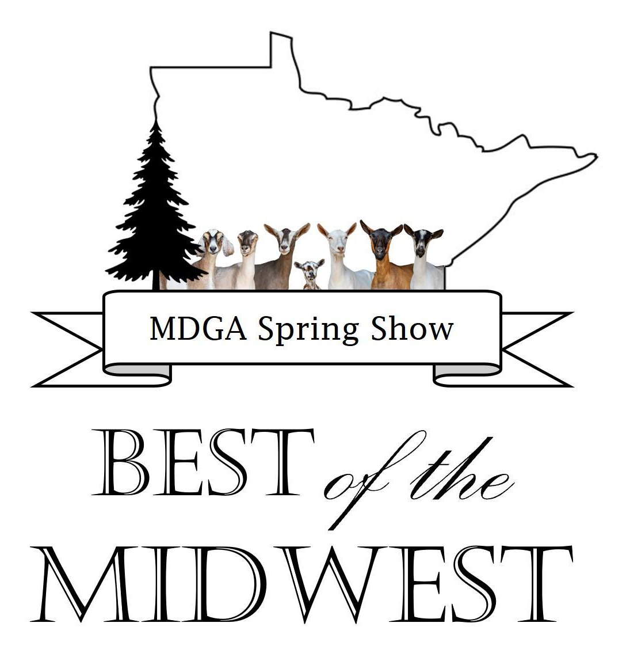
“Best of the Midwest” MDGA Youth Show
Fillmore County Fairgrounds
413 East Fillmore Street, Preston, MN
Saturday, May 30th, 2026
Registration May 29th after 5 and May 30th 6:30-7:30 am
Show begins at 9:00 am
This show is open to all youth who are 20 years of age and under.
Judges: Sara Hazeltine, Tyler Ramirez, George Andrew
Show Chair: Shellie Gilbertson

Online Entry is encouraged!
https://showman.app/shows#/2026-best-of-the-midwest---mdga-state-show-8363

- Show Order subject to change
- Showmanship will start with Pee Wee, Junior, and Intermediate 1, Then Int, 2 and Senior.
- Breed classes will have two judges judging at the same time. Order to be announced.
- Costume Class will be after group classes and before the start of the open class junior show.

Breeds and Show Order | Class | Description | Age
Alpine (A) | Y1 | Junior Kid | Born April 1, 2026 - present
LaMancha (L) | Y2 | Intermediate Kid | Born in March 2026
Nigerian Dwarf (D) | Y3 | Senior Kid | Born Jan 1 - February 28, 2026
Nubian (N) | Y4 | Dry Yearling | Never freshened, less than 24 months of age
Oberhasli (O) | Y5 | Milking Yearling | 1 year old in milk, less than 24 months of age
Saanen (S) | Y6 | 2 year old milker
Sable (B) | Y7 | 3-4 year old milker
Toggenburg (T) | Y8 | 5+ year old milker
Recorded Grade (R)
Unrecorded Grade (U)
Costume Class

 |  | Showmanship Classes | (Youth age as of May 30th, 2026)
Showmanship classes are free! Participation encouraged. Sign up online or at check in! | Y11 | 5 - 7 years old | Pee Wee
 | Y11 | 8 - 10 years old | Junior
 | Y12 | 11-13 years old | Intermediate 1
 | Y13 | 14-16 years old | Intermediate 2
 | Y14 | 17-20 years old | Advanced

Pen space is limited, and stalling will be done by the show committee - Please pre-register. Registrations completed online, emailed to, will be considered pre-registered, and may be paid for the day of the show. If not using online entry, send entries for the youth show emailed to secretarymdga@gmail.com or mailed to: Kirsten Zoellner 29537 Highroad, Fountain, MN 55935.

Awards and ribbons will be awarded.

NOTE: You may enter as many goats as you want in each class. Animals will be vet checked. You must provide your own bedding. Each youth is responsible for cleaning out their own pens after the show.
“Best of the Midwest” MDGA Youth Show
Fillmore County Fairgrounds
413 East Fillmore Street, Preston, MN
Saturday, May 30th, 2026

Online Entry is encouraged! https://showman.app/shows#/2026-best-of-the-midwest---mdga-state-show-8363
Exhibitor/Family Names: ___________________________ County: _______________
Scrapie Premise ID:_______________ Phone Number: ______________________
Address: ____________________________________________________________
Email Address ________________________________________________________
Pre-registration entered online by 9 PM CST on May 25th or postmarked by May 15th
(When reserving pens, only reserve for animals. There will be ample space for tack and storage.)

Item | Number | Cost | Total
# Pens Needed | x | $5
# Goats Attending | x | $4
Costume Class |  | free
Showmanship Class |  | free
Optional items:
MDGA Membership |  | $20
Farm Website listing in MDGA  member directory  (active membership required) |  | $5
TOTAL

xhibitor | Breed | Class # | Name of Goat | Birthdate of Goat
Please indicate which exhibitor is entering which animal/class. You may enter as many goats as you want in each class. Make copies as needed.

