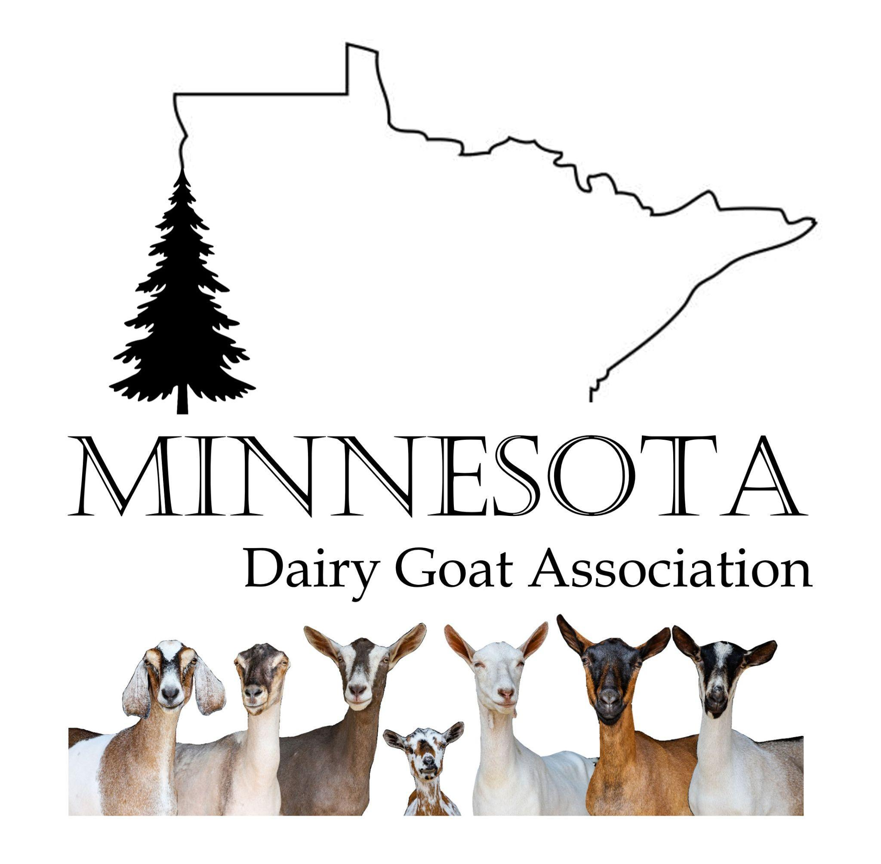
2027 Minnesota Dairy Goat Association
Outstanding Youth Guidelines

Applicants must be 16-19 years old as of January 1, 2027.
Contestants must reside in the State of Minnesota. The only exception is applicants who live outside the state for the sole purpose of being a full-time student.
Applicants or their parents/guardians must be current Minnesota Dairy Goat Association members.
Preference is given to students not selected as Outstanding Youth in previous years.
A dairy goat club, farm, business organization, or family must sponsor the applicant.
Applicants must be knowledgeable about dairy goats.
An application, resume, bio, and two letters of recommendation are required by July 31, 2026.
The resume must include name, address, age, interests, hobbies, a short history of dairy goat involvement, and a recent photograph.
Two letters of recommendation, by a non-family member, are required and may be sent with the application or directly from the person writing the recommendation.
Applications are to be sent to: Shellie Gilbertson,19482 443rd street, Zumbrota, MN 55992 or Northwindgoat@gmail.com, any questions call 507-993-7970.
A selection committee may conduct an oral interview to determine a winner. The representative will be chosen based on their interest in the dairy goat industry, personality, resume, and recommendations.
The winner will be announced at the Minnesota State Fair awards ceremony.

2027 Minnesota Dairy Goat Association
Outstanding Youth Duties

Assist the State Fair Youth Committee at events including, but not limited to the MDGA fall conference and the Best of the Midwest MDGA State Show. Represent the MDGA at the Minnesota State Fair Youth and Open Dairy Goat Shows, and other regional shows as they are able
Assist with awards ceremonies at the Minnesota State Fair Shows and promote and assist with the MDGA’s informative Goat booth at the Minnesota State Fair
Provide dairy promotions through newspaper articles, radio interviews, and other media, or attend and/or speak at special events as requested
Present an oral year-end report at the Fall General Membership Meeting

